LAB211 Assignment | Type: | Short Assignment
 | Code: | J1.S.P0074
 | LOC: | 100
 | Slot(s): | 2

Title
Write a calculator program (from DCPS’s project)
Background
NA
Program Specifications
Write a calculator program have functions: addition, subtraction, multiplication functions for matrix.

Function details:
Function 1: Display a menu and ask users to select an option.
- Users run the program. The program prompts users to select an option.
- Users select an option, perform Function 2.
Function 2: Perform function based on the selected option.
- Prompt users input number of row, number of column of 2 matrixes.
- Prompt users input values of matrixes must be the number. If users input values that are not a number, display notification on the screen: “Values of matrix must be the number”.

- Option 1: Addition matrixes
- Display result.
- Option 2: Subtraction matrixes
- Display result.
- Option 3: Multiplication matrixes
- Display result.
- Option 4: Exit program.

Expectation of User interface:
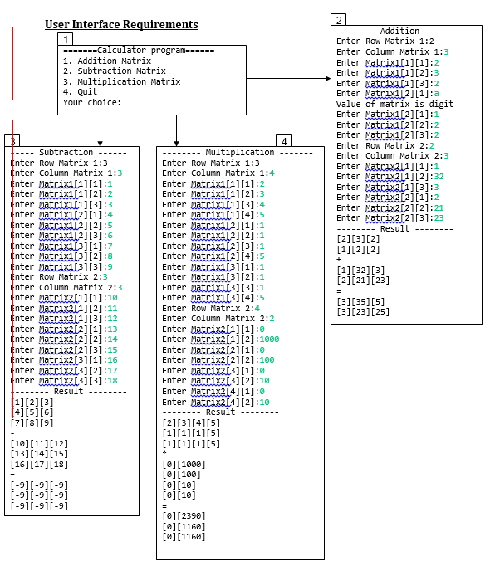

Guidelines

Student must implement methods
additionMatrix
subtractionMatrix
multiplicationMatrix
in startup code.

Function 1: Addition matrixes
- Implement function: public int[][] additionMatrix (int[][] matrix1, int[][]matrix2)
  - Input:
- matrix1: The first matrix.
- matrix2: The second matrix.
  - Return values: The result.
Function 2: Subtraction matrixes
- Implement function: public int[][] subtractionMatrix (int[][] matrix1, int[][]matrix2)
  - Input:
- matrix1: The first matrix.
- matrix2: The second matrix.
  - Return values: The result.
Function 3: Multiplication Matrixes
- Implement function: public int[][] multiplicationMatrix(int[][] matrix1, int[][]matrix2)
  - Input:
- matrix1: The first matrix.
- matrix2: The second matrix.
  - Return values: The result.

